Sean Yang

1/31/19

Pd 4

Journal report 15

I added an input box to put in the folder name for saving the images. It was a text entry box and you have to press enter to update the current folder. When I designed the input method, it didn’t sound too bad. Giving a specific folder name and saving the images works well. However, I sat down and thought about how my program works and the goal of the program. I decided to make the GUI component simpler and give users less options. First off, my classification script currently takes in specific folder names and decides what keypress should be simulated. It would be nice to have more features, but sometimes more is less. It’s sort of like the idea of the paradox of choice. For the purpose of my project, flipping pages, only three gestures are truly necessary: flip left, flip right, and do nothing. Those functions probably covers what most of the users of my program want. Having three buttons instead of a text box makes things more clear and less intimidating. My priority is to make my program more accessible and simpler. If I have extra time, I will make my program more customizable for people who want the features. I will make a script for the user to create their custom gestures and simulate other keyboard actions. I am running into some problems with the tkinter pack functions. The function pack(side = left) works for lining buttons up. However, I don’t quite understand how things get stacked and how to pack a button into a new line. It’s a minor issue and I should be able to figure it out soon. The first image is a screenshot of my old GUI and the second image is a screenshot for the new GUI. This is not final and functions such as clear gesture will be added soon.

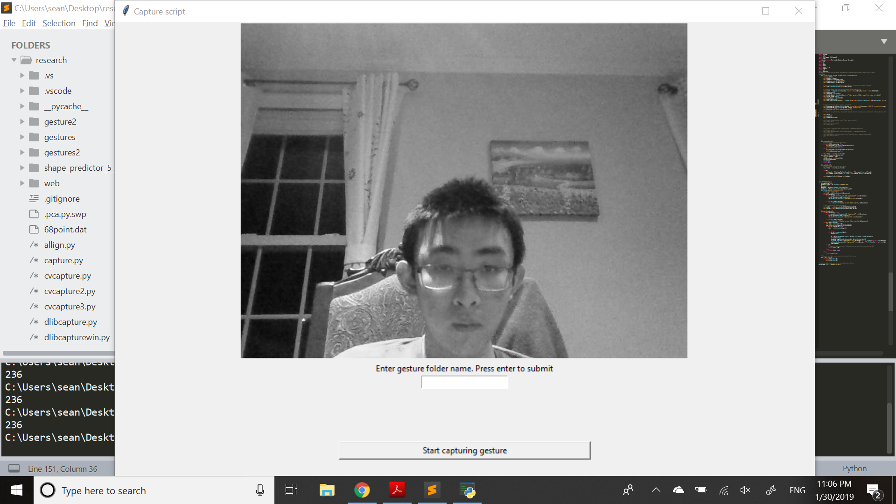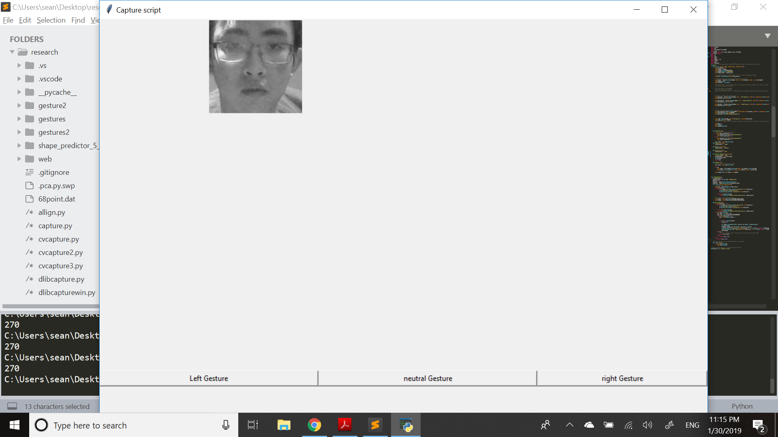

I also realized some of the difficulties with the web component of my project. Since my program works better when gestures are recorded by the user, I might have to save images with the web component. Saving images locally and clearing folders will be kind of annoying. I will have to talk to Evan or Omkar about how to solve the problem.